Torque Documentation

IRAN: Persepolis - Apadana, Detail of a Ring or Bracelet, Carried by a Saka Tigraxauda Tribute Bearer.
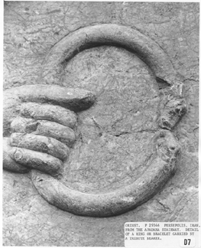
LINK TO HIGH RESOLUTION IMAGE - 430+ kilobyte file
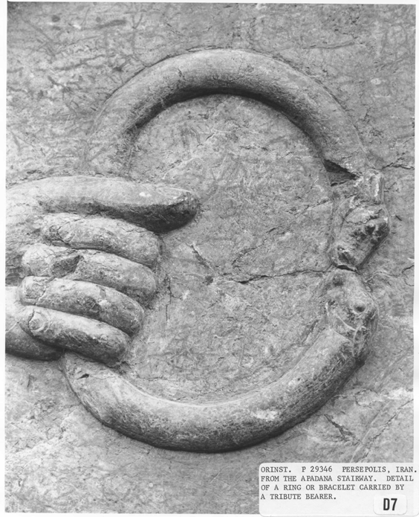

PERSEPOLIS AND ANCIENT IRAN

The Apadana
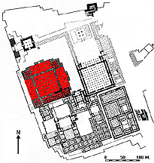

By far the largest and most magnificent building is the Apadana, begun by Darius and finished by Xerxes, that was used mainly for great receptions by the kings. Thirteen of its seventy-two columns still stand on the enormous platform to which two monumental stairways, on the north and on the east, give access. They are adorned with rows of beautifully executed reliefs showing scenes from the New Year's festival and processions of representatives of twenty-three subject nations of the Achaemenid Empire, with court notables and Persians and Medes, followed by soldiers and guards, their horses, and royal chariots. Delegates in their native attire, some completely Persian in style, carry gifts as token of their loyalty and as tribute to the king. These gifts include silver and gold vessels and vases, weapons, woven fabrics, jewelry, and animals from the delegates' own countries. Although the overall arrangement of scenes seems repetitive, there are marked differences in the designs of garments, headdresses, hair styles, and beards that give each delegation its own distinctive character and make its origin unmistakable. Another means by which the design achieves diversity is by separating various groups or activities with stylized trees or by using these trees alone to form ornamental bands. There is also an intentional usage of patterns and rhythms that, by repeating figures and groups, conveys a grandiose ornamental impression.

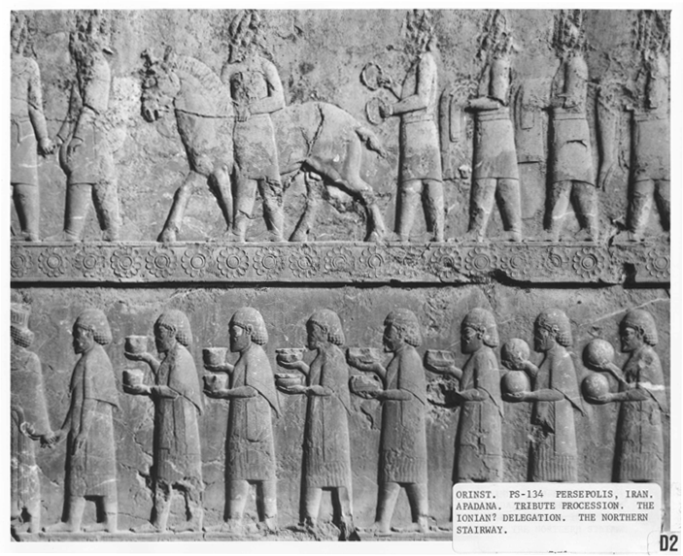

PERSEPOLIS TERRACE: ARCHITECTURE, RELIEFS, AND FINDS
The magnificent palace complex at Persepolis was founded by Darius the Great around 518 B.C., although more than a century passed before it was finally completed. Conceived to be the seat of government for the Achaemenian kings and a center for receptions and ceremonial festivities, the wealth of the Persian empire was evident in all aspects of its construction. The splendor of Persepolis, however, was short-lived; the palaces were looted and burned by Alexander the Great in 331-330 B.C. The ruins were not excavated until the Oriental Institute of the University of Chicago sponsored an archaeological expedition to Persepolis and its environs under the supervision of Professor Ernst Herzfeld from 1931 to 1934, and Erich F. Schmidt from 1934 to 1939.

